UX Phase 2

Name :Aaysha Begam A

Emp.ID :761155

Steps To Run Angular

1. Type this command in node.js ng serve

2. if any port error is displayed, then change port number by

ng serve –port=9990(You can give any port number)

3.It give “compiled successfully”

Here I give screenshot of angular run commands

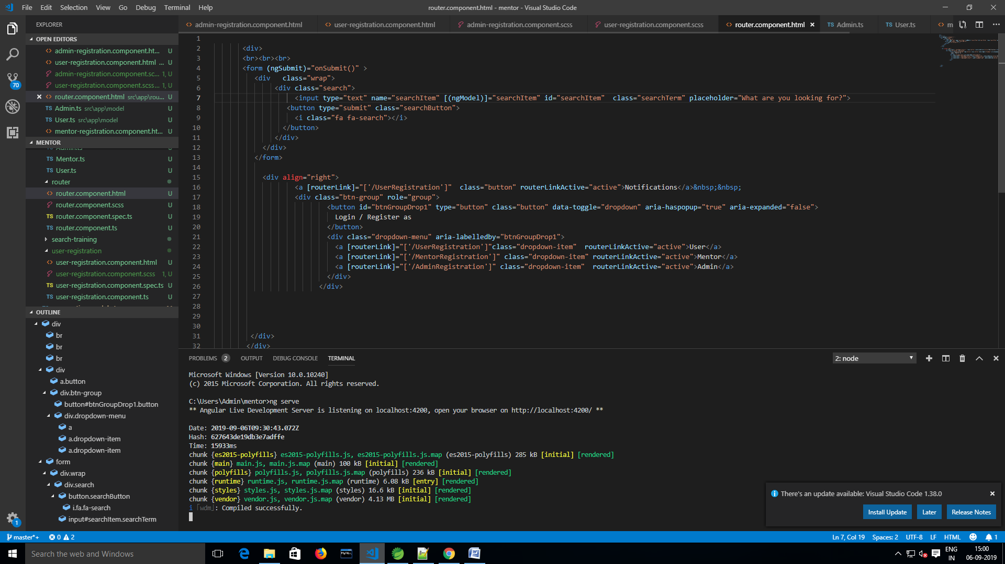

Home Page:

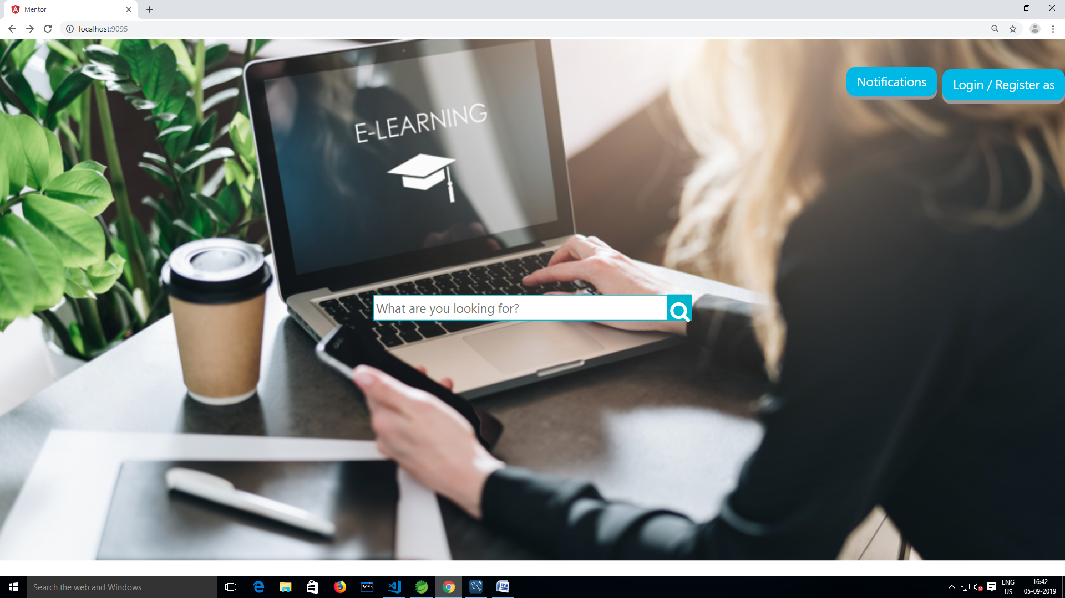

After Click Login/Register As Choose User,Admin,Mentor

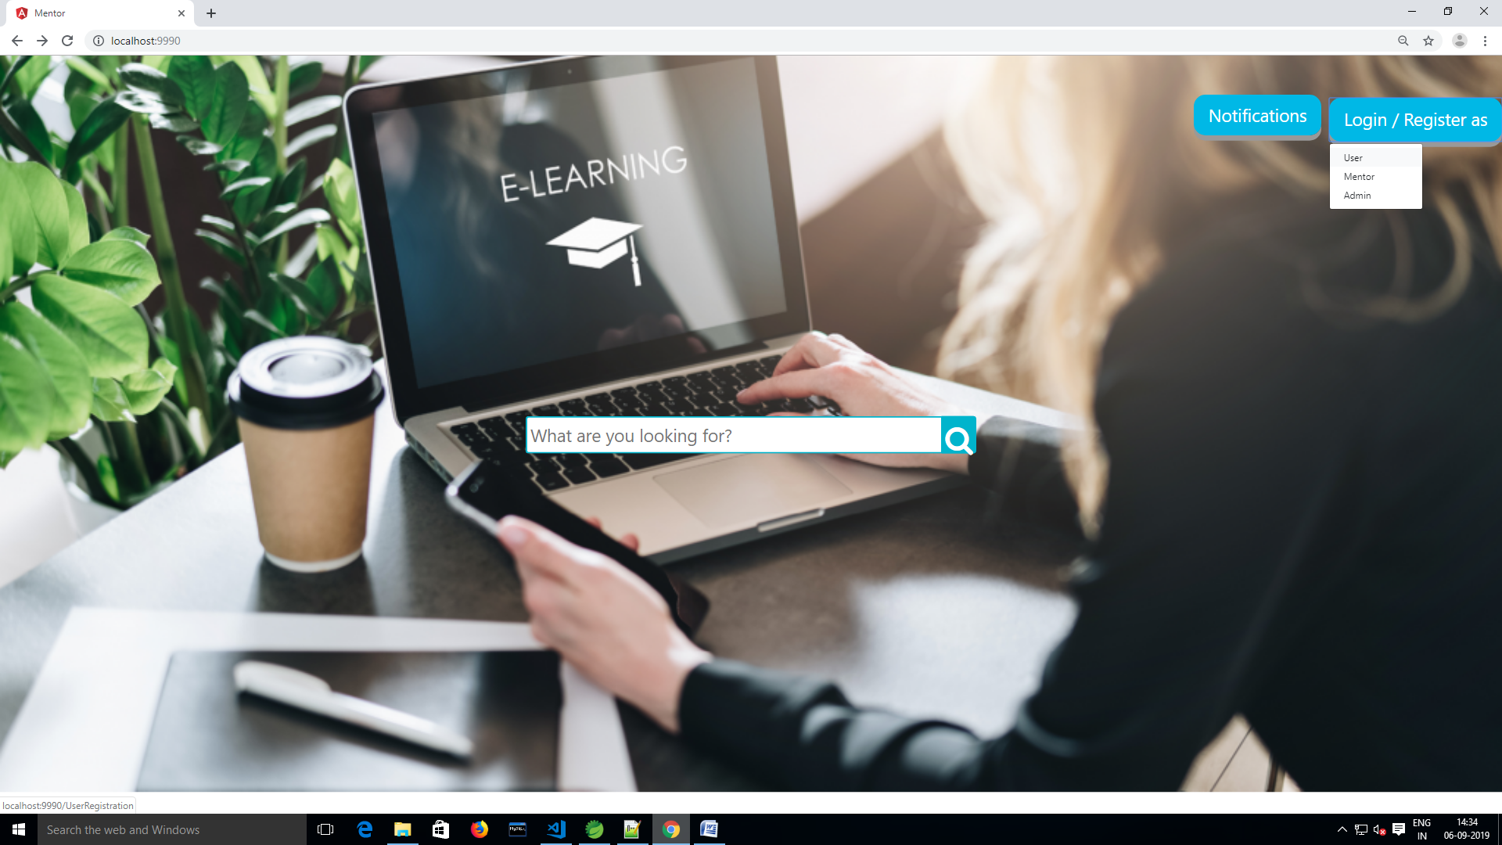

Mentor Sign Up Page:

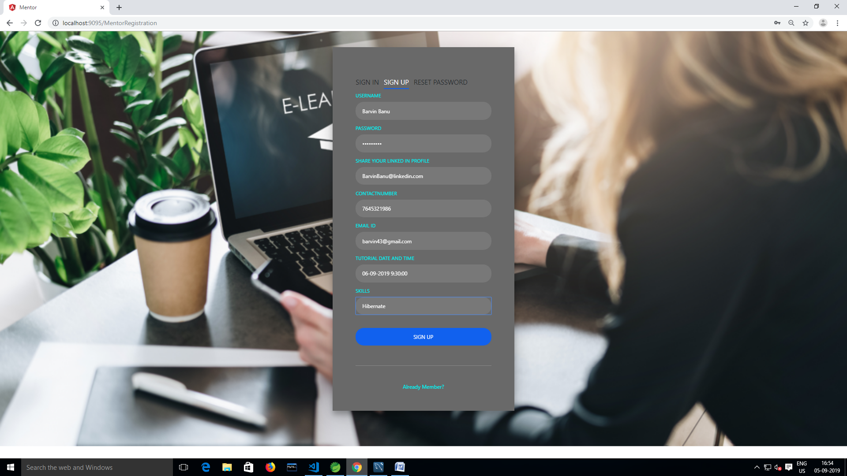

After Sign Up Mentor Details Saved in Database

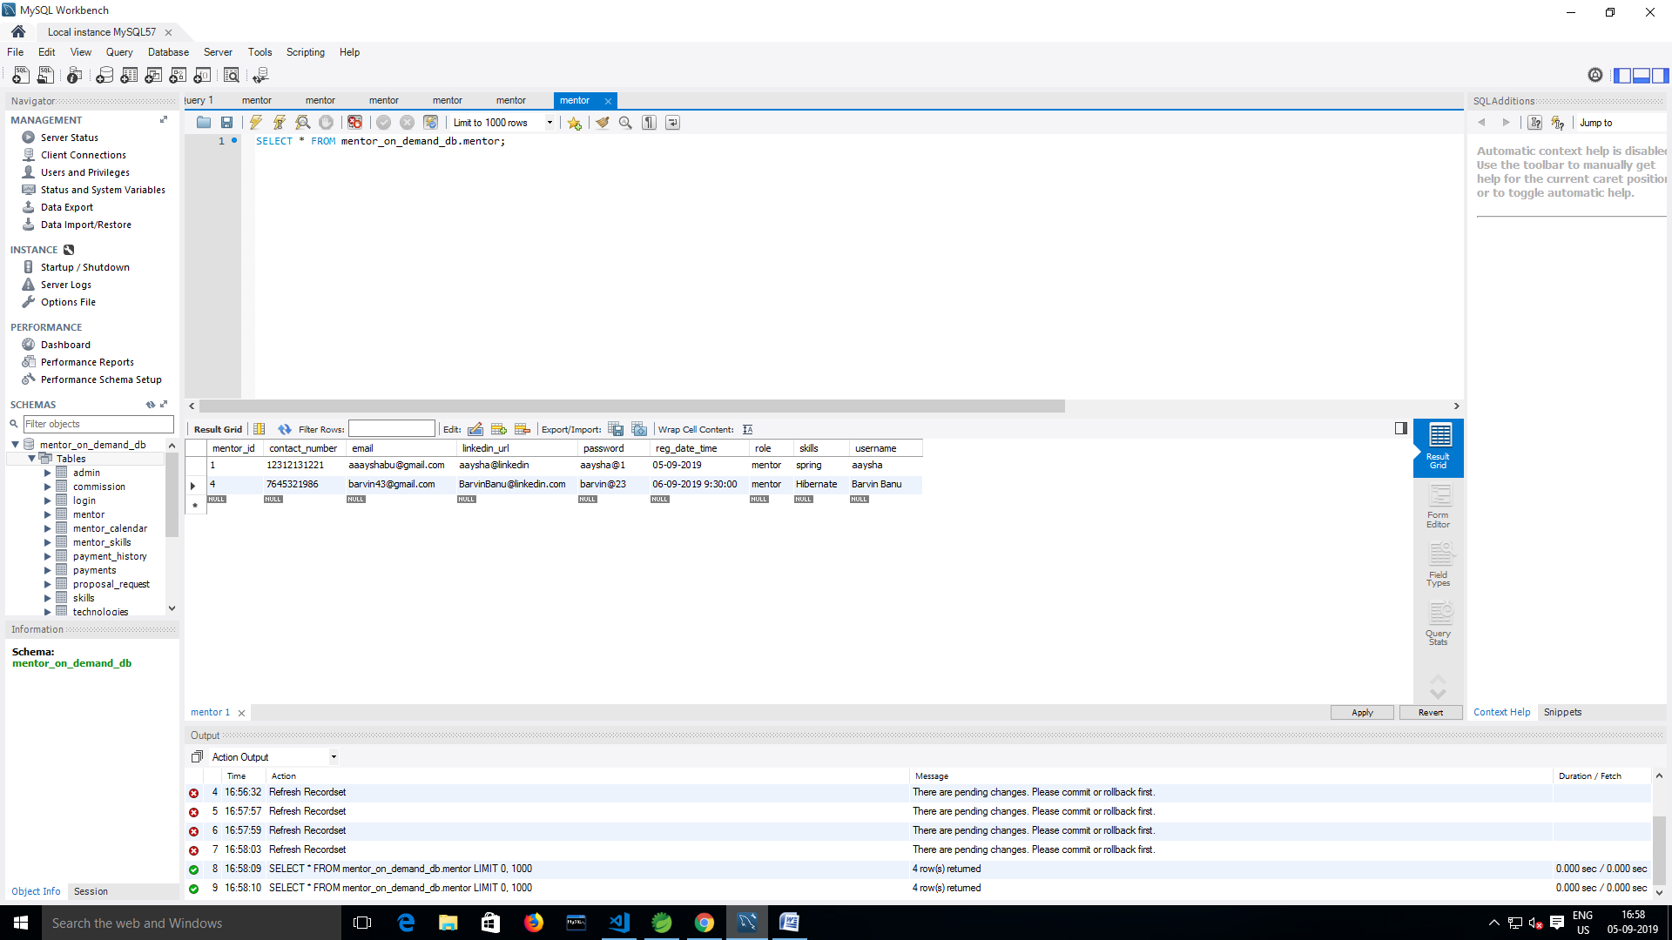

User Sign Up Page

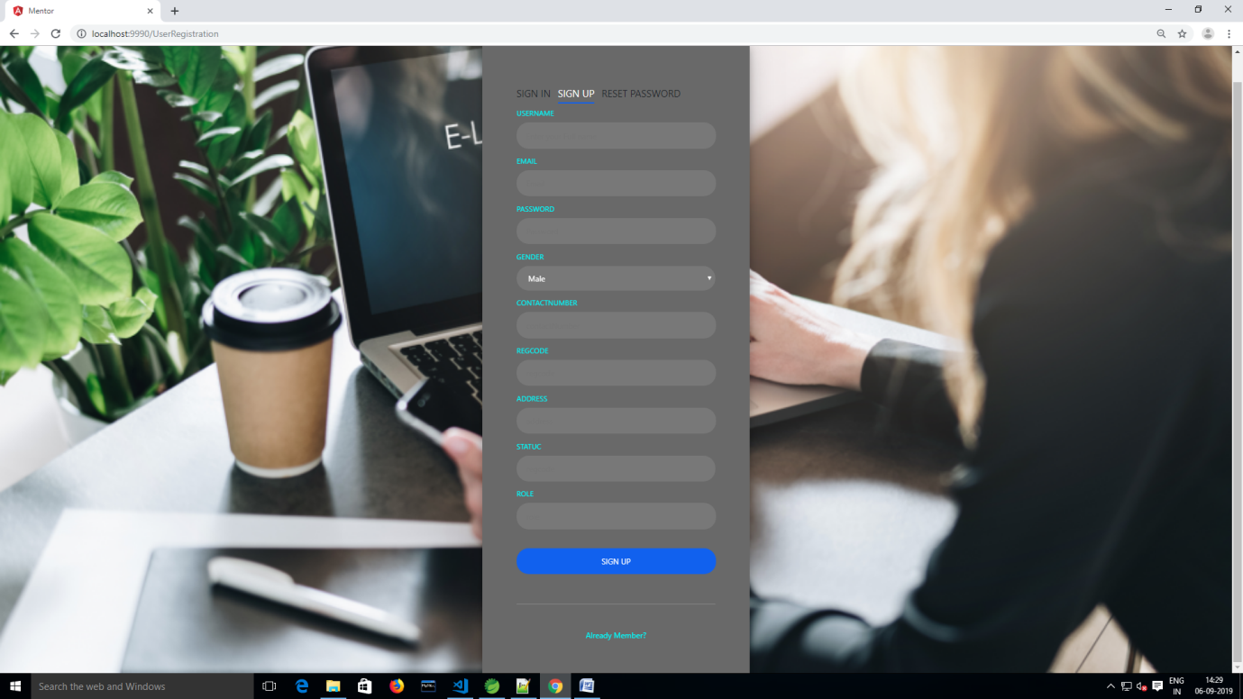

User Sign In Page

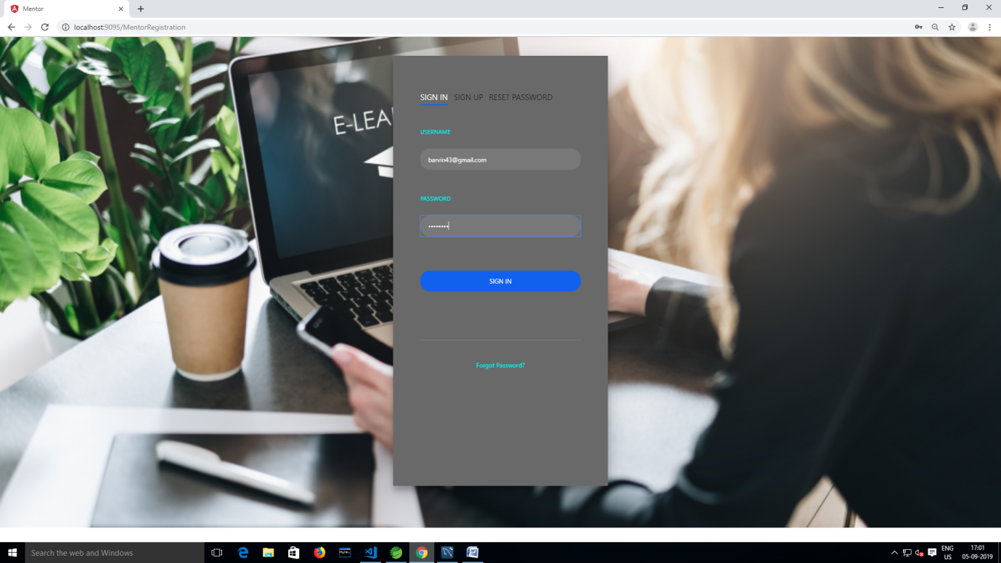

Any User Search “Spring” Related Training in Search Button

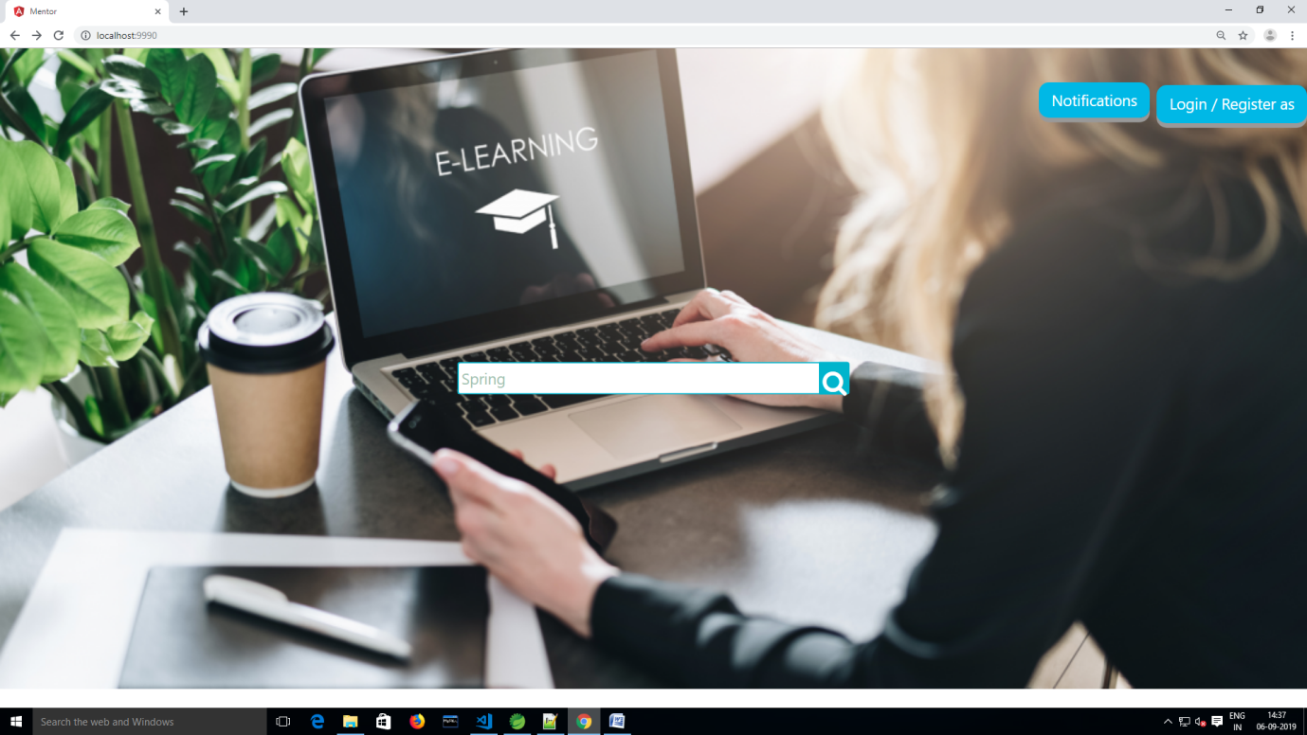

Results For Search “Spring” Related Training

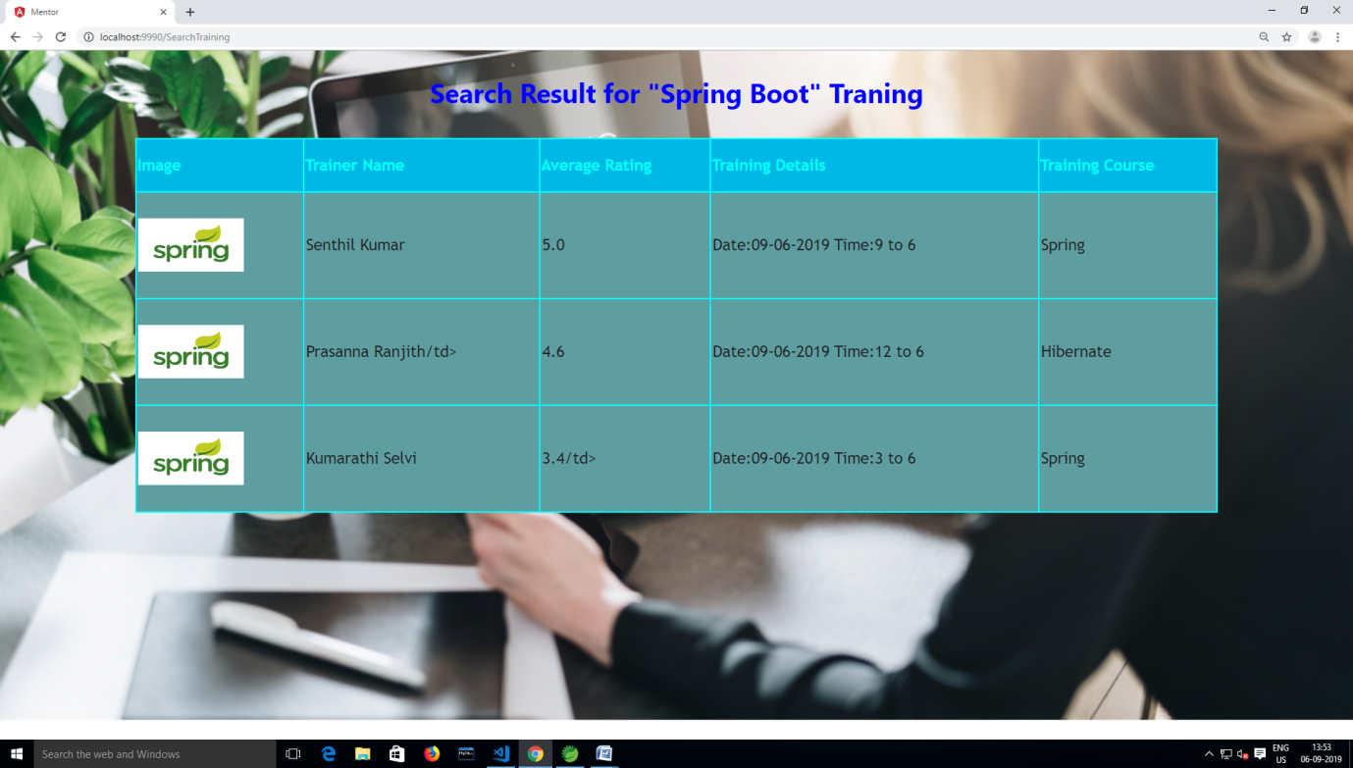

Admin Sign Up Page

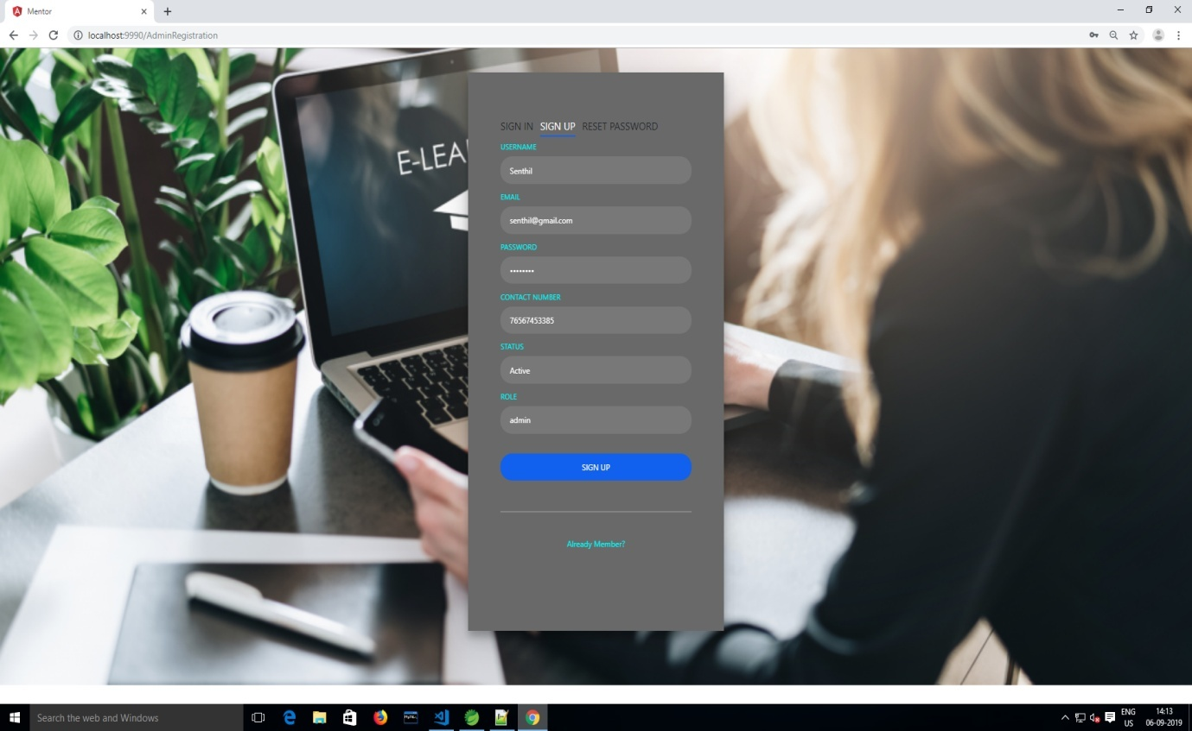

Admin Sign In Page

